EXP 34

AIM : Design DFA using simulator to accept even number of c’s over the set {a,b,c}

INPUT:

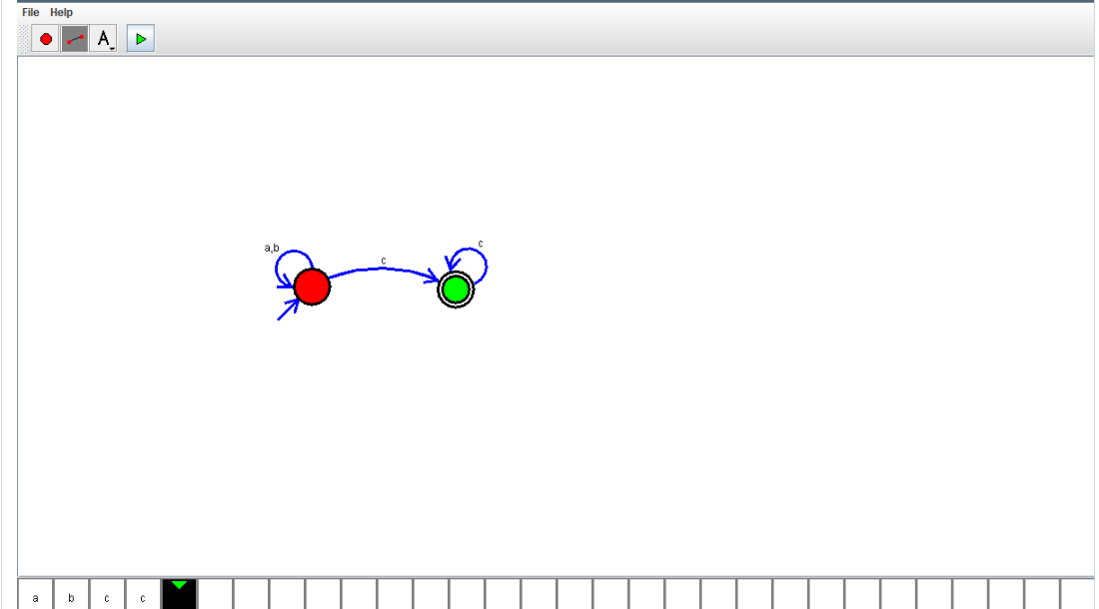

OUTPUT:



RESULT:

DFA using simulator to accept even number of c’s over the set {a,b,c} is verified